Middleware Programming: Project Report

Volunteer Website

Priyam Rao

Prof. Nguyen Quach

2/7/2021

CONTENTS | PAGE NUMBER
INTRODUCTION | 3
DESCRIPTION OF YOUR WORK | 4
USER MANUAL | 6
CONCLUSION | 8

INTRODUCTION:
To create the website for volunteer organization. I have used different technologies. I would like to introduce them.

HTML:
Hypertext Markup Language (HTML) is the standard markup language for documents designed to be displayed in a web browser. It can be assisted by different technologies. Web browsers receive HTML documents from a web server or from local storage and render the documents into multimedia web pages. HTML describes the structure of a web page semantically and originally included cues for the appearance of the document. HTML elements are the building blocks of HTML pages. With HTML constructs, images and other objects such as interactive forms may be embedded into the rendered page. HTML provides a means to create structured documents by denoting structural semantics for text such as headings, paragraphs, lists, links, quotes and other items
CSS:

This is the technology that can assist the HTML. CSS is often used for Styling and making the webpages more attractive and impactful. CSS stands for Cascading Style Sheets. CSS describes how HTML elements are to be displayed on screen, paper, or in other media. CSS saves a lot of work. It can control the layout of multiple web pages all at once. External stylesheets are stored in CSS files

JavaScript:

Till now, we saw the technologies for basic design and structure and styling. JavaScript is the programming side of the website design. While designing the website we must make sure that the website works smoothly without any problems and errors. Using JavaScript, we can put programming restrictions on the website usage and make sure that the user does not misuse its content. It is often abbreviated as JS, is a programming language. JavaScript is high-level, often just-in-time compiled, and multi-paradigm. It has curly-bracket syntax, dynamic typing, prototype-based object-orientation, and first-class functions.

Web Browser:

To run the HTML file we need the web browser. We can use any web browser and

DESCRIPTION OF YOUR WORK:

I have designed webpages using the HTML, CSS and JavaScript. I am going to put the screenshot of one of the main thing in those webpages and that would be the registration form.

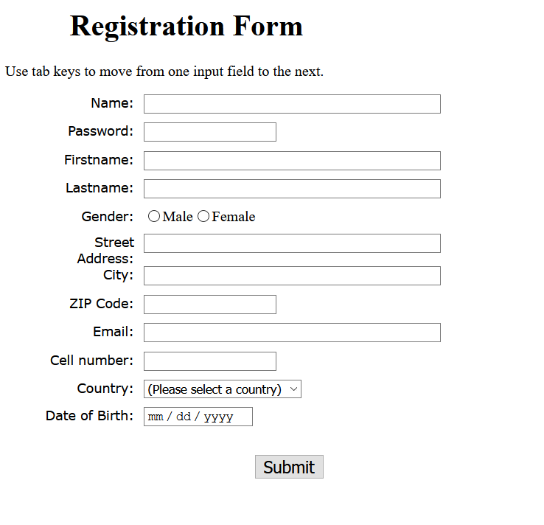
There are different files. The one we’ll discuss about is Form1.html

The file is used to create the basic registration page and the required CSS and JS files are linked to it using the links to the files. So, when their functionalities are required then it would be accessible. The next file would be the form.css file. This file is about styling the webpage and give unique design to the registration form. Now the last file is form2.js. this file is the JavaScript file. This file contains different validation functions for the data entered by the user in registration form. I am putting a screenshot of the JavaScript file.

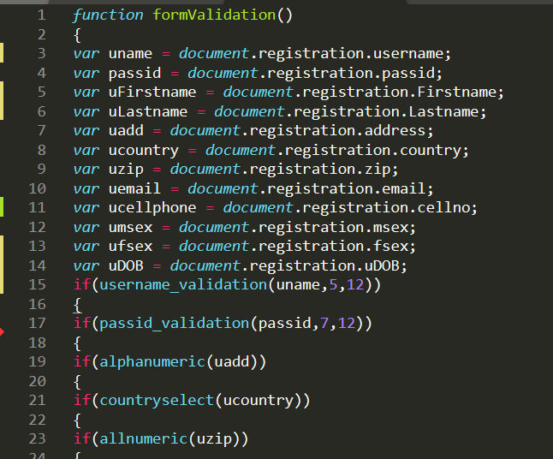
In this screenshot all the files can be seen.

USER MANUAL:

- As I mentioned earlier there are three different files required to run this webpage. The files might be three but you don’t need all three files to run the code.
- What you need to do is to use any browser of your choosing and run the HTML file. Once you run that file you will reach the registration form.
- Then you can register your details. The JavaScript functions will make sure you don’t enter any inappropriate data. If you do it won’t accept the data.
- Once you have successfully run the webpage and filled the registration details. You can submit the details. Now, it is not linked to the database, so the website can’t store your information. But when the website will be linked then once you register and create the login credentials, you can access the website using that.

To run the program, you can right click on the html file and choose- open with, then you can choose the web browser of your preference and open the file in it..

You can run this web page like that. It is pretty simple.

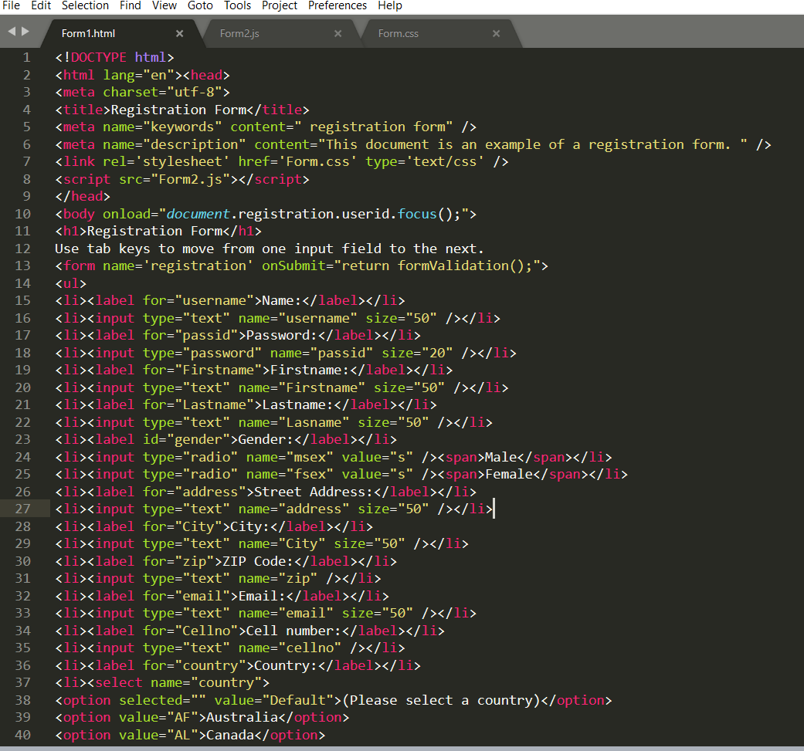

CONCLUSION:

- What I achieved: I was not very familiar with these technologies. But while working to create this website, I realized that the technologies I was not very familiar with, now I can work with them. Besides that, I am now able to design websites on my own. The objective was to design the volunteer website by the time I will finish, I would have my own created website.
- What I learned: As I already said that I was not familiar with these technologies. But while designing the web page I started learning a lot and I am sure by the time I am finished I will learn a lot more and be capable of designing more dynamic and complex structured websites. And I would be able to do that efficiently, hopefully. I learnt how to use HTML, CSS and JavaScript together.
- Challenges: While working with HTML and CSS, I did not face many challenges. But after finishing work with this two, when I tried to incorporate JavaScript, then it became a little difficult. In the beginning I was unable to use the JavaScript Function.
- How I Overcame: Well, I started watching a lot of JavaScript videos, After watching many videos, I finally grasped the concepts and then I tried to finish the task. There is still room for improvement. I’ll try to make it better as I go forward with the project.

